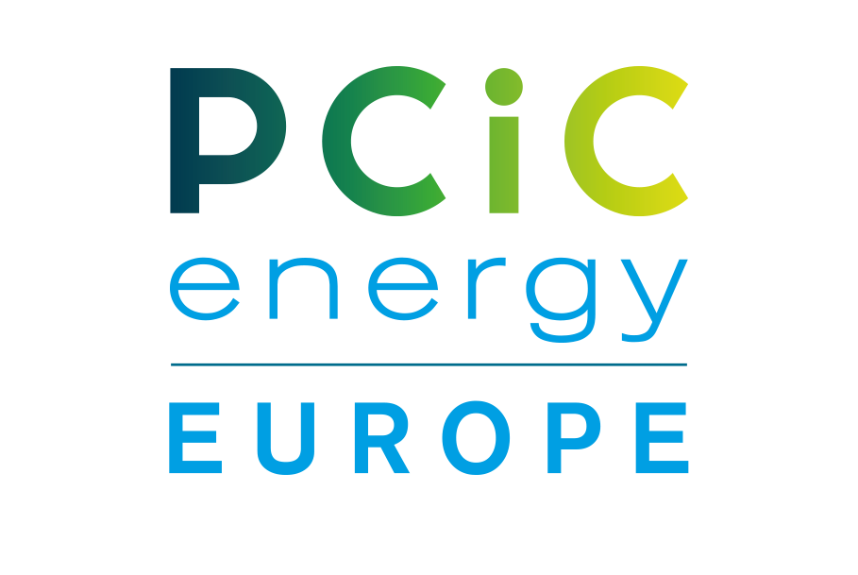
PCIC energy Europe 2024 Conference – Rotterdam/Netherlands
Hilton Rotterdam – Weena 10 – 3012 CM - Rotterdam
Dates : 4-6th June 2024
ORDER FOR SPONSORSHIP
To be sent to: Susanne.messerli@schneider-treuhand.com / cc sponsorsteam@pcic.energy
Date of Order
Company/Ordered by
Sponsorship level
Delegate Package /
other Sponsor options
Total Sponsorship Invoice | €
Payment terms | Within 30 days of order being placed.
Billing address
Order reference to be mentioned on the invoice
Invoice to be sent to :
Contact / Email address
Tel or Mobile No
Stand contact name with Email address & Tel/Mob no:

For marketing posts provide Name & Contact Email address for Marketing Team to approach.
Sponsor table Required Yes/No  (Included in Sponsorship) | YES / NO
Interest to received Hospitality Suite information | YES / No
COMPANY LOGO | Please attach File with Form
Date: Signature: Company stamp:

