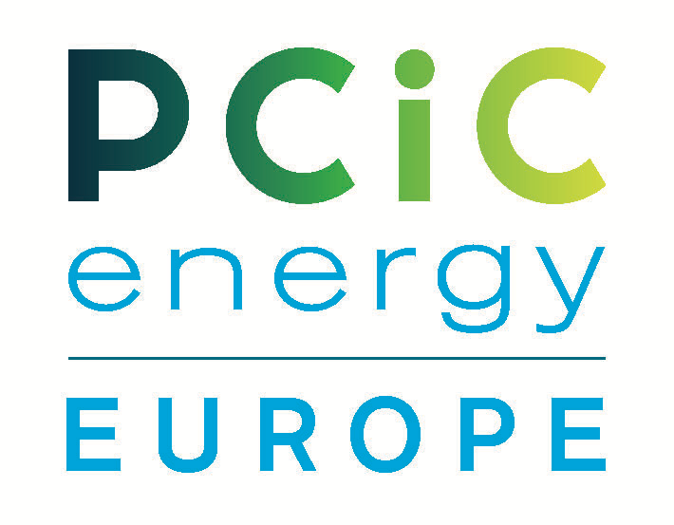
PCIC energy Europe 2023 Conference – Milan/Italy
FAST / Federazione delle Associazioni Scientifiche e Tecniche,
Milan 6-8th June 2023
ORDER FOR SPONSORSHIP
To be sent to: Susanne.messerli@schneider-treuhand.com / cc sponsorsteam@pcic.energy
Date of Order
Company/Ordered by
Sponsorship level
Billing address
Order reference to be mentioned on the invoice
Name of the contact person to whom the invoice has to be sent
Email address of the contact person
For marketing provide Name & Contact Email address
Sponsor table Required Yes/No
(Included in Sponsorship)
Total amount in €
Payment terms
COMPANY LOGO | Please attach with Form
Date: Signature: Company stamp:
ALL FIEDS ARE MANDATORY

